**Assignment 1**

Name: Aditya Matale

Class: AI-B Batch: B1

Roll No.: 25

**Install Google App Engine. Create and execute hello world app using python/java**

Main.py

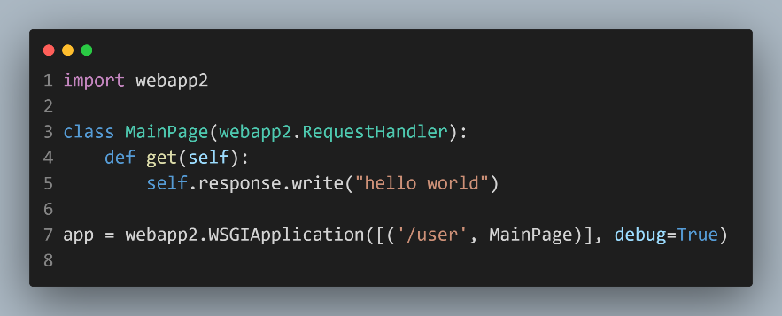

App.yml

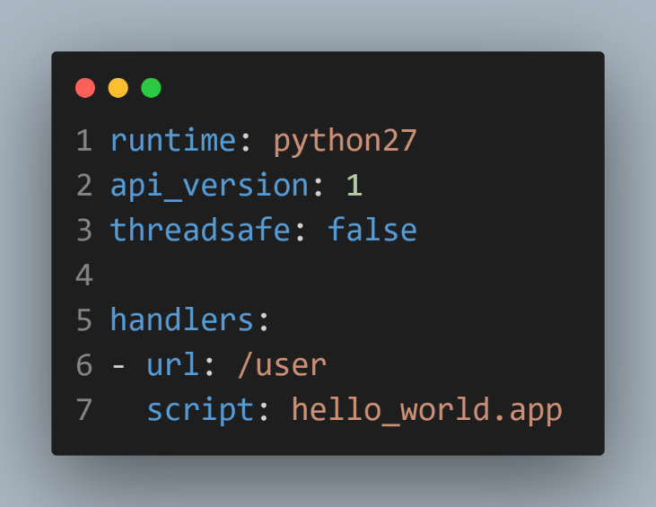

OUTPUT

